February 15, 2022 Vol. 73, No. 7

When to Return to Church? (Hint: Now)  A recent op ed in Baptist New Global warned against live streaming worship. In the short piece, the author wrote about the “superiority of gathered sanctuary worship to pajamas living room worship.” Distractions and the temptation to skip some parts of worship loom for the one live streaming.  With all due respect to the author, I disagree with his premise. I know people who cannot come to worship in person. They have health issues. Or, last Sunday, for example, one couple was traveling to care for their aging parents. Why would we exclude people from joining our fellowship? The live stream is for these people. The author’s argument sounds to me a bit like ableism, or discrimination in favor of able-bodied people. Still, I cannot help but wonder about the temptation to stay home and participate via “pajamas living room worship.” For those who can come to worship in person but choose to stay home, they miss the communal aspect of worship.  In a selfish sense, you deprive me of you. Watching the live stream isn’t a voyeuristic activity when you comment, email, call, or text one of us ministers later. Your contact is a reminder to those of us in the sanctuary that you were with us in spirit. For those who can come, we miss the chance to see you and hear about how you are doing. YouTube and Facebook Live lack the incidental conversations that happen in the aisles before and after worship.  In The Atlantic, Yascha Mounk argues to “open everything.” He wrote in March of 2020 to “cancel everything.” Now, with vaccines freely available to everyone over 5 years old and antiviral pills right around the corner, Mounk suggests that we have the tools to live with the virus. The New York Times has been reporting about easing restrictions and lifting mask mandates. WBUR had a similar story about state mask mandates. Now is the time to regather.  UBC is blessed with big spaces. Our sanctuary seats over 600 people. Almost everyone in worship (probably 100% on many Sundays) is fully vaccinated. We can spread out and practice safe social distancing, especially in the balcony. People who are concerned about the continuing spread of the coronavirus can come to worship at the last minute and sneak out during the postlude without ever speaking to another person. We can regather safely.  God is doing some amazing things through this body of believers, and we want you to be a part of it. We want to see you and walk in faith with you as the world learns to live with Covid. So, when should you return? Now. (I would add the caveat: those who are unable to join worship in person because of health concerns, please continue to stay safe and watch online). But don’t just come back on Sunday morning. Come around the church other times. Stick your head in the office and say hello, or get involved in one of the exciting projects at UBC.  I hope to see you soon!  Peace,  Matt |  | SERVICE OF HOLY WORSHIP﻿  February 20, 2022  11:00 AM  Sermon  "Badly Keeping Score"  Rev. Will Brown  Scripture:  Luke 6:27-38  Anthem:  "Wade In The Water," arr. Hayes  Deacons: Raynell Stokes  Ushers: Herman and Gail Eaker  CALENDAR  WEDNESDAY, Feb. 16  9:00 Work Team  10:00 PBJ (Zoom)  12:00 Wednesday Treats  7:00 Sanctuary Choir Practice  THURSDAY, Feb. 17  7:00 PM Seekers Class (Zoom)  SATURDAY, Feb 19  10:00 Budgeting for Students﻿  SUNDAY, Feb. 20  8:30 Finance Committee Meeting  10:00 Sunday Bible Study  11:00 Morning Worship  5:00 Jubilate Rehearsal  MONDAY, Feb. 21  Church Office Closed  8:30 Morning Prayer (UBC  Facebook Page)  10:30 Bible Reading Group (Zoom)  1:00 Schleiermacher Reading Group (Zoom)  TUESDAY, Feb. 22  9:30 Staff Meeting  6:30 Prayer Shawl Group  For our most up-to-date calendar, click here.  Prayer Needs  Alice Batten - Home  Sympathy to Alba and Pam Beasley after the death of Pam's mother, Dotty Blevins, on February 8.  HAPPY BIRTHDAY!!  Join us in wishing some of our church family a Happy Birthday this week!  February 24: Mary Jo Hendricks  February 25: Laura Martindale  February 26: Jay Hendricks  February 28 (29): Shelley Payne  March 1: Laura Centofante  March 2: Suzanne Smith
Brightening a Neighbor's Day
A few months ago, when the fall weather turned (arguably) too cold for soft serve ice cream, we decided to begin giving away coffee and hot chocolate on Wednesday afternoons. From noon until 2:00 each week, we have been stationed on the front sidewalk to give away drinks and treats to our neighbors. Would you like to help?
It's a joy to hand someone a hot drink and reassure them that it really is free. Whether it's a UVA student, a hospital employee, a patient on the way to their appointment, or anyone else, we have had a wonderful experience wishing these neighbors a good day. We would love for you to join us in this ministry. It's fun and easy, with no preparation required. Just come with a warm coat and a smile. Feel free to drop by any time. You can sign up on this sheet to let us know when you can help, either with preparation or distribution: Sign Up Here Thanks for your participation in this ministry!
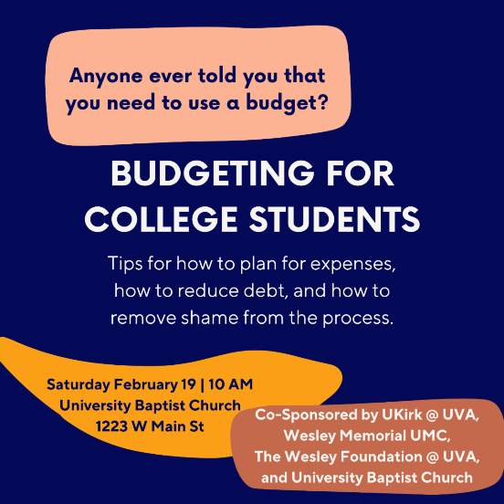
Budgeting Seminar for College Students Saturday, 2/19
STUDENTS: You are invited to join us this Saturday, February 19, at 10 AM for a seminar on budgeting. In addition to being taught a basic plan for budgeting, you will receive tips on how to plan for expenses, how to reduce the debt you incur during college, and how to remove shame from the process of becoming financially aware in this phase of life. This easy system will be one you can follow now and into the next phase of life after college, helping you plan for the unexpected moments in the future, while still enjoying your favorite Roots bowl now!

We will meet 10 AM to 12 PM in the children's suite on the second floor. Coffee and hot drinks provided; masks required for all attendees. Register Here.
WMU of Virginia Accepting Applications for
Refugee Exploration Trip
WMUV and WMU NC are taking a team to Italy July 17-27, 2022 on an educational trip with the goal of understanding the refugee journey process and how we can make a difference internationally and in Virginia and North Carolina. Italy is both a destination and a transitional country for refugees. We will learn more about the refugee journey, including humanitarian and integration work, before and while a resettlement country is being determined. The approximate cost is $2200 and the deadline to apply is March 1. However, if you are very interested and cannot complete the application by March 1, please contact Laura Davis at LDavis@wmuv.org ASAP to discuss an extension on this deadline. Click Here to learn more.
Bible Study Resuming
This Sunday, and throughout the month of February, we will resume a (slightly) shorter in-person study. Instead of a deep-dive Bible study, our focus will be more devotional. We will meet at 10am in the Fellowship Hall and conclude by 10:30 to reduce the risk of spreading covid by shortening the time we are together.

Our study for February will be the prophet Micah. You can get the handout by clicking here. Dr. Matthew Tennant will lead this study.

February 6 – Intro & Micah 1
February 13 – Micah 2-3
February 20 – Micah 4-5
February 27 – Micah 6-7

To enhance conversations among the participants, we will not offer an online option. For those who are unable to attend but still want to join a group, the Open Minds class does offer a hybrid option. Contact Debra Bryant or Ed Lowry for details. If you have any questions, please contact Dr. Tennant.
Voces Laetae!
A NEW Vocal Ensemble for Youth Ages 14-19
Auditions are underway at UBC for a new youth vocal ensemble. Please share this information with friends and family to help spread the word!

Voces Laetae! will rehearse on Tuesday evenings from 7:00-9:00 PM beginning February 22, 2022, with culminating concerts to be given in May 2022. There is no participation fee. CDC masking guidelines will be followed. Further questions may be sent to voceslaetae@gmail.com.
Writing Leave for Senior Minister
The UBC Personnel Committee recommended and the Church Council approved an additional six-week leave for Senior Minister Matthew Tennant, DPhil, in 2022. From April 25 through June 5, Matt will take time away from UBC to complete a book he has been writing for several years (Freedom and Existence: The Existentialism of Liberation Theology). The Personnel Committee and Church Council recognize the additional challenges in leading UBC during the pandemic, and we anticipate that Matt’s rest and rejuvenation during these weeks away will boost his return to ministry at UBC.

Val Fisk and Will Brown will share pulpit duties with Reverend Kim Bunns, who has preached at UBC previously. If you have questions, feel free to reach out to the chairpersons of the Personnel Committee (Jen May) or Church Council (Peter Ohlms).
Sunday Mornings
Worship
Our Sunday morning worship service will begin at 11:00 am. We encourage everyone in the congregation to join us in whatever way you feel safe and comfortable at this time, whether in person or virtually. As always, you can listen by radio on WINA (1070 AM and 98.9 FM), or you can join us online for our live broadcast. To view the live video broadcast, visit our Facebook page or click this link to watch on YouTube.

Masks & Social Distancing
University Baptist Church continues to follow the recommendations of the CDC as they are updated. At this time, that means that all individuals, both vaccinated and unvaccinated, should wear a mask for all in-person gatherings in the church building. As we monitor this next wave of COVID cases related to the Delta and Omicron variants, we will make announcements as our policies are adjusted.

University Baptist Church  1223 West Main Street  Charlottesville, VA 22903  434-293-5106 | Connect with us  ‌ ‌ ‌

